**CloudFoundry Services**

In this lab, you’ll practice creating, binding and managing services using both the CLI and the web console.

**Prerequisites**

To complete these steps, you must have the CLI installed, a Cloud Foundry account (Such as Pivotal Web Services), Additionally, the “Spring Music” application should have already been pushed to Cloud Foundry.

Finally, you will need some database client software to connect to the new database that you will provision.  DBVisualizer, Toad, SquirrelSQL, and many other tools that work with JDBC will suffice.  Install / use the tool of your choice.

ACCESS CREATED SERVICES FROM OUTSIDE

1.      Target and login to your Cloud Foundry instance as shown by the earlier labs. You may still be logged in from before.

2.      Obtain a listing of all of the services / plans available in the marketplace.  This listing can vary depending on the Cloud Foundry environment you are connected to:

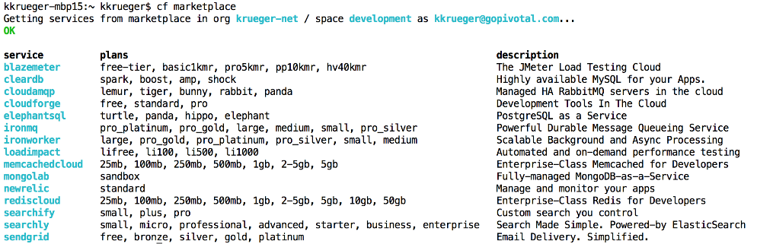

3.             Create a new MySQL service.  On PWS this service is known as “cleardb”

a.    Use the “spark”[Free*] plan since our storage requirements are modest.

b.    Give the service any name you like, but remember the name for later.

https://studio.biglms.com/c4x/PivotalAcademy/PCF100/asset/lab6-2.png

4.             If needed, push the spring-music application to Cloud Foundry.  This was done in an earlier exercise so you have probably already done this.

5.             Bind spring-music to the service you have just provisioned.



6.             Restart the app to make sure it uses the new service

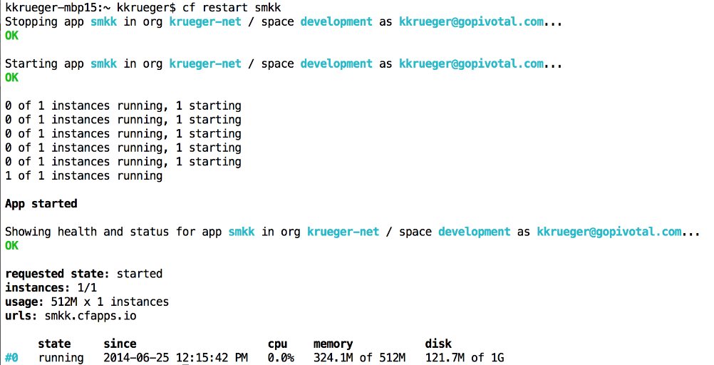

7.             Use a browser to open the application’s URL.  Navigate through the application and see there is data there.  (Note that this application has an ‘embedded’ database that is used when no other DB is available, this is why it worked before the service was bound.  So how can we tell if it is using the ‘bound’ database or the ‘embedded’ database?  Next step…)

8.             Obtain the DB credentials.  You can do this via the Web Console: Find the details of your application, go to Bound Services, click on credentials.

9.             Open your database client, create a MySQL connection and point it to the MySQL you just provisioned.

10.          See you can query and modify data accessing that database directly. Add or modify a new Album.  Does this album show up on the web page?

11.          Stop the application

12.          Congratulations, you have caused Cloud Foundry to provision a database for you, and have learned how to access it directly.